 | MONDIAL JEUNES  Under 18 / Under 23  CHIERI (Italie) | 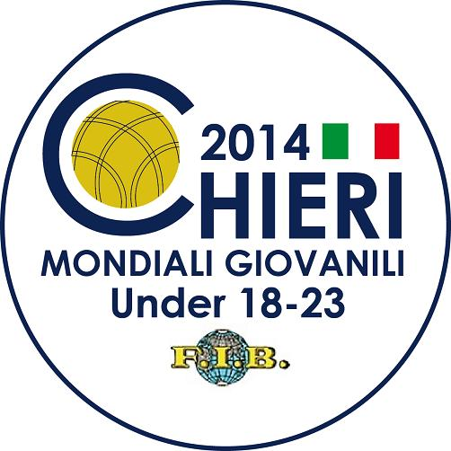

 | TIR RAPIDE EN DOUBLE - TIRO VELOCE A COPPIE

QUALIFICATIONS
1. | TUR | HAMDI R/OZTURK F | 35/57 | Q | 12. | TUN | KHMIRI K/KHIARI H | 37/55 | Q
2. | BRA | MATTUELLA E/BRIANSINI F | 22/49 | Q | 13. | ARG | HECKER L/CAMARGO J | 31/57 | Q
3. | MON | BRESCIANO G/TRICHARD Q | 32/54 | Q | 14. | URU | PAOLINO R/FAGIAN P | 18/51 | Q
4. | CRO | BRNIC L/MILICEVIC M | 53/61 | Q | 15. | MAR | ZERWAL A/ARGUIEL S | 11/51
5. | BUL | RADEV F/GEORGIEV I | 10/51 |  | 16. | CIV | LOGBO D/GAOYE O | NC
6. | MNE | PETKOVIC A/CULE Y | 24/48 | Q | 17. | SVK | OBROCNIK D/PAVCO P | 18/50 | Q
7. | FRA | ABELFO G/MARSENS F | 50/60 | Q | 18. | BIH | CORLUKA A/MIKULIC N | 35/54 | Q
8. | DJI | SAMATAR M/HAMZA M | Abs |  | 19. | SRB | BUTORAC S/SARAC U | 39/52 | Q
9. | ITA | MANA S/CARRU S | 40/59 | Q | 20. | PAR | ZARATE C/CACERES D | 17/53 | Q
10. | AUS | SAMSA D/GIACOMETTI T | 13/50 |  | 21. | PER | LUNA M/ALTAMIRANO J | 39/58 | Q
11. | SLO | KAVCIC M/URBANCIC D | 45/58 | Q

1/8ème DE FINALE
1. | PAR | ZARATE C/CACERES D | 17/53 |  | 9. | BIH | CORLUKA A/MIKULIC N | 42/56 | Q
2. | URU | PAOLINO R/FAGIAN P | 26/50 |  | 10. | TUN | KHMIRI K/KHIARI H/ | 39/55 | Q
3. | SVK | OBROCNIK D/PAVCO P | 13/50 |  | 11. | SRB | BUTORAC S/SARAC U | 37/55 | Q
4. | BRA | MATTUELLA E/BRIANSINI F | 14/47 |  | 12. | PER | LUNA M/ALTAMIRANO J | 32/57
5. | MNE | PETKOVIC A/CULE Y | 26/48 |  | 13. | ITA | MANA S/CARRU S | 46/60 | Q
6. | ARG | HECKER L/CAMARGO J | 35/58 |  | 14. | SLO | KAVCIC M/URBANCIC D | 45/59 | Q
7. | MON | BRESCIANO G/TRICHARD Q | Abs |  | 15. | FRA | ABELFO G/MARSENS F | 48/61 | Q
8. | TUR | HAMDI R/OZTURK F | 44/57 | Q | 16. | CRO | BRNIC L/MILICEVIC M | 55/60 | Q

1/4 DE FINALE
1. | SRB | BUTORAC S/SARAC U | 40/54 |  | 5. | SLO | KAVCIC M/URBANCIC D | 47/59 | Q
2. | TUN | KHMIRI K/KHIARI H/ | 36/55 |  | 6. | ITA | MANA S/CARRU S | 42/59
3. | BIH | CORLUKA A/MIKULIC N | 38/56 |  | 7. | FRA | ABELFO G/MARSENS F | 52/61 | Q
4. | TUR | HAMDI R/OZTURK F | 44/58 | Q | 8. | CRO | BRNIC L/MILICEVIC M | 51/60 | Q

1/2 FINALE
1. | TUR | HAMDI R/OZTURK F | 44/58 |  | 3. | CRO | BRNIC L/MILICEVIC M | 53/60 | Q
2. | SLO | KAVCIC M/URBANCIC D | 46/60 |  | 4. | FRA | ABELFO G/MARSENS F | 57/60 | Q

FINALE
1. | CRO | BRNIC Leo / MILICEVIC Marino | 59/61 |  | 2. | FRA | ABELFO Guillaume / MARSENS F. | 56/61

PODIUM
 | CRO | BRNIC Leo / MILICEVIC Marino
 | FRA | ABELFO Guillaume / MARSENS F.
 | SLO | KAVCIC Matej / URBANCIC Damjan | TUR | HAMDI Rusten / OZTURK Faik Rustum

