 | MONDIAL JEUNES  Under 18 / Under 23  CHIERI (Italie)  23 au 27 Septembre 2014 | 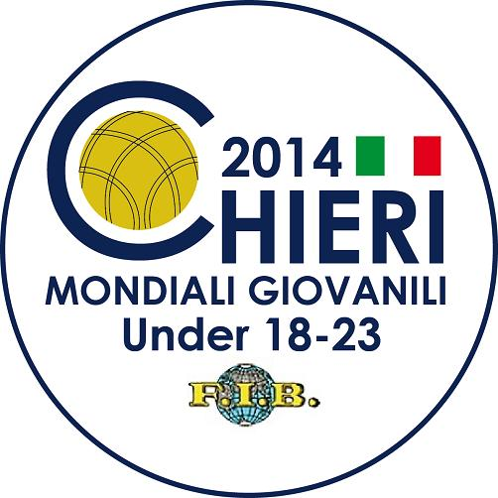

 | TIR RAPIDE EN DOUBLE - TIRO VELOCE A COPPIE

QUALIFICATIONS
1. | TUR | HAMDI R/OSTURK F | 35/57 |  | Q
2. | BRA | MATTUELLA E/BRIANSINI F | 22/49 |  | Q
3. | MON | BRESCIANO G/TRICHARD Q | 32/54 |  | Q
4. | CRO | BRNIC L/MILICEVIC M | 53/61 |  | Q
5. | BUL | RADEV F/GEORGIEV I | 10/51
6. | MNE | PETKOVIC A/CULE Y | 24/48 |  | Q
7. | FRA | ABELFO G/MARSENS F | 50/60 |  | Q
8. | DJI | SAMATAR M/HAMZA M | Abs
9. | ITA | MANA S/CARRU S | 40/59 |  | Q
10. | AUS | SAMSA D/GIACOMETTI T | 13/50
11. | SLO | KAVCIC M/URBANCIC D | 45/58 |  | Q
12. | TUN | KHMIRI K/KHIARI H | 37/55 |  | Q
13. | ARG | HECKER L/CAMARGO J | 31/57 |  | Q
14. | URU | PAOLINO R/FAGIAN P | 18/51 |  | Q
15. | MAR | ZERWAL A/ARGUIEL S | 11/51
16. | CIV | LOGBO D/GAOYE O | NC
17. | SVK | OBROCNIK D/PAVCO P | 18/50 |  | Q
18. | BIH | CORLUKA A/MIKULIC N | 35/54 |  | Q
19. | SRB | BUTORAC S/SARAC U | 39/52 |  | Q
20. | PAR | ZARATE C/CACERES D | 17/53 |  | Q
21. | PER | LUNA M/ALTAMIRANO J | 39/58 |  | Q

1/8ème DE FINALE
1. | PAR | ZARATE C/CACERES D
2. | URU | PAOLINO R/FAGIAN P
3. | SVK | OBROCNIK D/PAVCO P
4. | BRA | MATTUELLA E/BRIANSINI F
5. | MNE | PETKOVIC A/CULE Y
6. | ARG | HECKER L/CAMARGO J
7. | MON | BRESCIANO G/TRICHARD Q
8. | TUR | HAMDI R/OSTURK F
9. | BIH | CORLUKA A/MIKULIC N
10. | TUN | KHMIRI K/KHIARI H
11. | SRB | BUTORAC S/SARAC U
12. | PER | LUNA M/ALTAMIRANO J
13. | ITA | MANA S/CARRU S
14. | SLO | KAVCIC M/URBANCIC D
15. | FRA | ABELFO G/MARSENS F
16. | CRO | BRNIC L/MILICEVIC M

